

 Wallet Walkthrough – Hands-on Wallet Setup  
  
**Objective/Aim:**  
  
To understand and perform the process of downloading, installing, and setting up a MetaMask wallet on a mobile device for managing digital assets securely.

**Apparatus/Software Used:**

* Phone(Android)
* Internet Connection
* MetaMask

**Theory/Concept:**

MetaMask is a popular crypto wallet that allows users to store, send, and receive cryptocurrencies, as well as interact with decentralized applications (DApps). It supports Ethereum and other EVM-compatible blockchains.

The wallet uses a **seed phrase** (Secret Recovery Phrase) for account backup and recovery.



**Procedure:**

· **Download the App**

* Open the Google Play Store (Android) or Apple App Store (iOS).
* Search for **"MetaMask"** and download the official app.

· **Install and Open MetaMask** 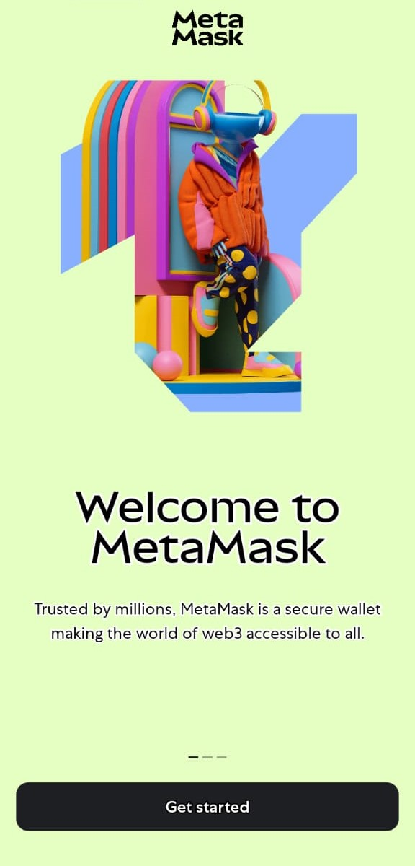 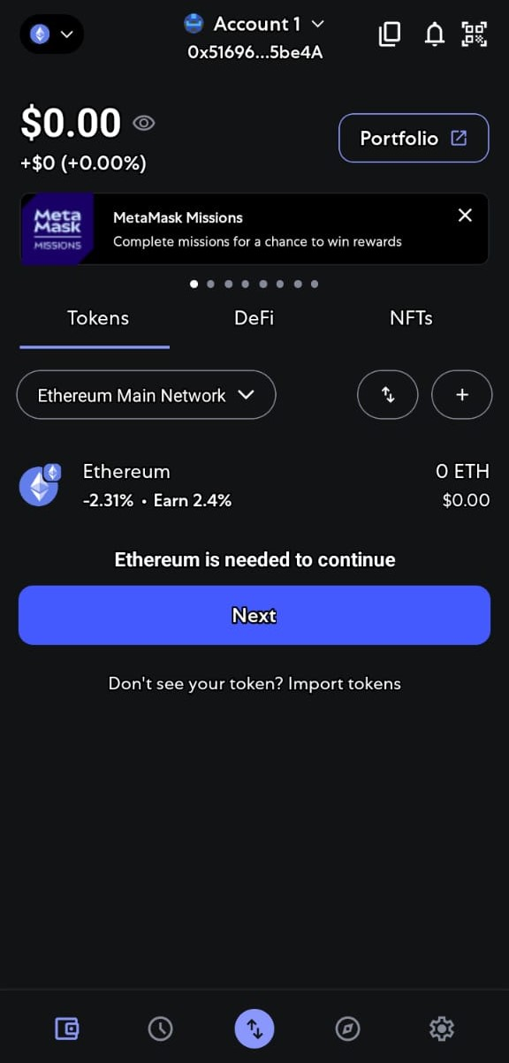

* Launch the app after installation.
* Read and accept the welcome screen information.

· **Create a New Wallet**

* Tap on **"Create a new wallet"**.
* Set a strong password (at least 8 characters with a mix of letters, numbers, and symbols).

· **Secure the Wallet**

* The app will display your **Secret Recovery Phrase** (12 words).
* Write it down on paper and store it in a safe, offline location.
* **Do not** share it with anyone.

· **Confirm the Recovery Phrase**

* Select the words in the correct order as shown earlier to verify.

· **Access Your Wallet**

* After confirmation, you will be redirected to your MetaMask wallet dashboard.

· **Explore Features**

* Check wallet address, view balance (initially 0), and explore send/receive functions.

**Observation:**

* MetaMask mobile provides a user-friendly interface.

* Secret Recovery Phrase is the only way to restore the wallet.

* Supports adding custom tokens and multiple networks.

* Includes built-in browser for accessing DApps.



|  |  |  |  |
| --- | --- | --- | --- |
|  |  |  |  |
|  |  |  |  |
|  |  |  |  |
|  |  |  |  |
|  |  |  |  |
|  |  |  |  |
|  |  |  |  |







